Community and Voluntary Sector Panel
Terms of Reference

Context
Community planning focuses on promoting positive outcomes for everyone. It is about public, private and community and voluntary organisations working together, to plan and deliver better services which make a real difference to people’s lives. Communities are at the heart of this process and community engagement is vital so that communities have a say in how public services develop and can be improved.
Connected: A Community Plan for the Armagh City, Banbridge and Craigavon Borough 2017-2030 is the overarching strategic plan for the borough. It contains a long-term vision and nine long-term outcomes arranged under the strategic themes of Community, Economy and Place.
The Armagh City, Banbridge and Craigavon Community Planning Strategic Partnership provides an overarching framework for partnership working within the borough. Additionally, there are a number of other structures that support governance and delivery of the plan. These structures include a number of Thematic Action Planning teams, Communications and Engagement Working groups and the Community and Voluntary Sector Panel.
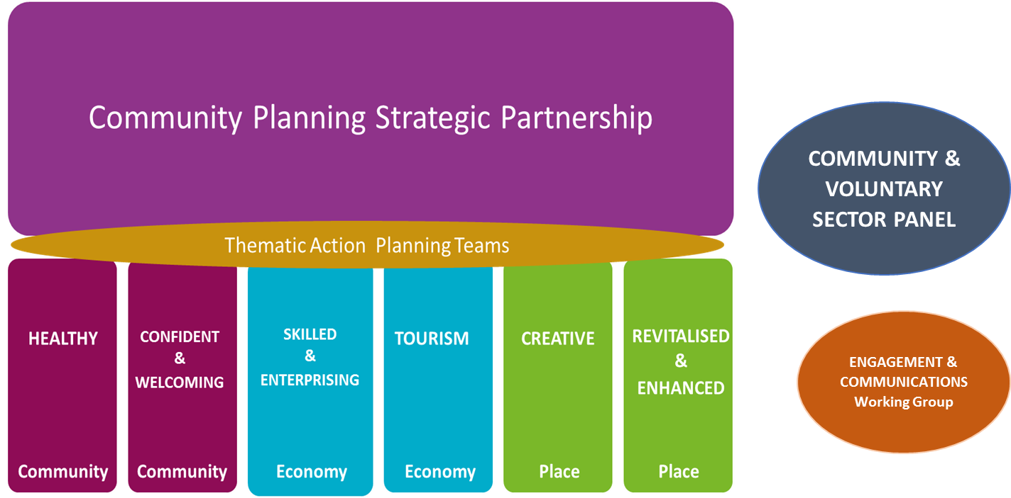

Role and Purpose of the Community and Voluntary Sector Panel
The role and purpose of the Community and Voluntary Sector Panel is to;

Ensure the Community, Voluntary and Social Enterprise Sector is represented
- to influence the community planning process through participation in the governance structure
- to nominate representatives to sit on the Community Planning Strategic Partnership, the six Thematic Action Planning Teams and the Communications and Engagement Working Group
- to build the capacity of the Community and Voluntary Sector to effectively participate in the community planning process

Promote ongoing Community Engagement
- to promote broad community engagement in the community planning process, including all section 75 groups and across the borough
- to connect the wider community and voluntary sector and existing partnerships, networks, forums and inter-agencies into the community planning process
- to act in an advisory capacity to the Engagement and Communications Working Group

Articulate the voice of the Community and Voluntary sector
- to act as a communications conduit ensuring two-way flow of information and communication between the community planning structures and the wider sector and communities
- ensure the views, experiences and needs of those sections of the community who are seldom heard, are expressed, acknowledged and considered
- assess how work of the Partnership and implementation of Plans meet the needs of those most marginalised and disadvantaged over time

Support the development of Cross-sectoral Relationships and improved Partnership working
- to increase collaboration between voluntary, statutory and business sectors through panel member participation in both the Community Planning Strategic Partnership and Thematic Action Planning Teams

Adopted Principles/Code of Conduct
The Community and Voluntary Sector Panel has adopted the following Principles to guide its work:
- Selflessness
- Integrity
- Objectivity
- Openness and Accountability
- Honesty
- Leadership
- Participation and Partnership

Membership
Membership of the Community and Voluntary Sector Panel is open to individuals from CVS organisations and networks from across the borough. Membership is limited to one person per group or organisation.

Following an engagement process with the Community and Voluntary Sector, it was agreed that all members should;

- have a good understanding of the needs of different communities experiencing inequality and disadvantage within and across the Council area, including S75 groups and communities of place.
- be committed and able to gather views of the wider sector to feed into the community planning process and to disseminate and share information about the community planning process with the sector.
- be committed to signing an agreed code of conduct/way of working as a group
- have experience and/or knowledge of one or more of the thematic areas from the community plan
- be either a Trustee/Director, Volunteer or staff member of a constituted community, voluntary or social enterprise organisation operating within the ABC Council area.
- be willing and able to attend meetings of the community and voluntary sector panel and where appropriate/applicable attend thematic team and partnership meetings in order to ensure there is community representation across the levels of decision making within the community planning process.
- be drawn from different geographical areas across the borough and from a mix of rural and urban communities.

Membership of the Community and Voluntary Sector Panel will be for a period of three years after which membership will be reviewed and a new panel will be recruited. These terms of reference will be subject to review by the Community and Voluntary Sector Panel and the Community Planning Strategic Partnership.

Roles and Responsibilities
The Community and Voluntary Sector panel will be chaired by a Panel member chosen from the Panel membership. All members are required to demonstrate commitment and be willing to contribute to collaborative working.

All Panel members will support the progression of the community plan by:
- Participating in panel meetings, action planning teams/strategic partnership meetings and communications and engagement working groups to deliver on the community plan
- Working with team members to identify actions, develop and agree action plans and ensure delivery against planned outcomes
- Taking a lead in actions when required
- Carrying out allocated tasks as agreed at meetings
- Contributing to effective community engagement in the development and implementation of action plans
- Engaging with other Community and Voluntary Sector groups and with communities within the borough. Effective and meaningful public participation will help to ensure action plans and decisions are responsive and reflect local needs.
- Promoting inclusivity by identifying hard to reach groups and appropriate methods of engagement.
- Contributing to the collection of relevant data for performance management
- Developing relationships across the borough to foster collaborative working

The Chair’s responsibilities will include;
- Chairing meetings
- Agreeing agendas
- Allocating/reviewing/co-ordinating actions between meetings
- Ensuring each action is attributed to an owner
- Ensuring feedback from members attending the Thematic Action Plan teams, Community Planning Strategic Partnership and Communications and Engagement Working Groups
- Ensuring that the Panel reports on progress as required
- Reporting back to Strategic Partnership
- Agreeing and reviewing performance management

Conflict of Interest
This is an open and transparent process and documentation in relation to the Community and Voluntary Sector Panel will be publicly available. Conflicts of interest may arise. It is the responsibility of Panel members to identify any potential conflict and to declare it to the Chair. Any conflict of interest will be recorded in the minutes.

Reporting Arrangements
A consistent and concise reporting template will be developed to support the gathering of information and facilitate reporting. The Community Planning Strategic Partnership will report to the Department for Communities every two years and progress will also be reported to stakeholders and the wider community.

Decision Making
All Panel members are required to demonstrate commitment and be willing to contribute to collaborative working. To enhance collaborative working decisions will be made by consensus as far as possible.

