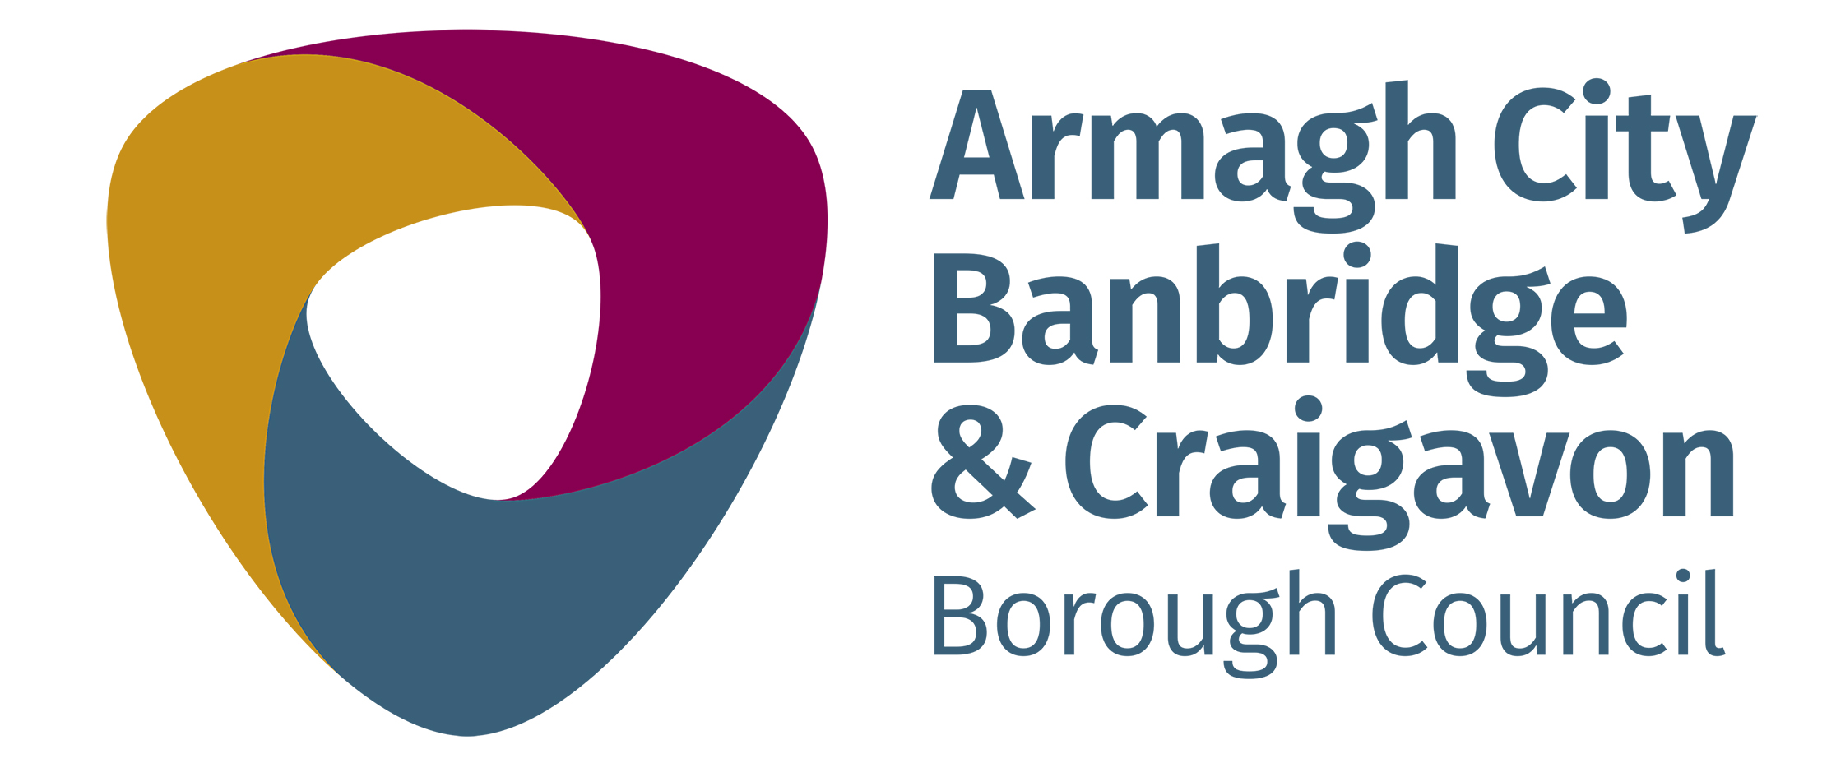

Project | Armagh City Banbridge and Craigavon Borough Council Urban Centre Identities
Competition | Survey Draw
Issued | Issued as part of the Armagh City, Banbridge and Craigavon Borough Council Urban Centre Identities Survey closing midnight on the 16th August 2020
Terms and conditions | By entering this competition, an entrant is indicating his/her agreement to be bound by these terms and conditions.  This competition is being promoted and managed by Armagh City, Banbridge and Craigavon Borough Council in partnership with Whitenoise Ltd.  Entrants must be over 18 years of age  This competition is open to individuals who complete and submit a response to the Armagh City, Banbridge and Craigavon Urban Centre Identities survey.  Employees and Elected Members of Armagh City, Banbridge and Craigavon Borough Council, Haller Clarke or Whitenoise Ltd, or their family members, or anyone else connected in any way with the competition or helping to set up the competition are not eligible to qualify for the prize (although they are welcome to complete the survey).  One entry per person per town centre is acceptable. Additional entries will not be accepted.  There is no entry fee and no purchase necessary to enter this competition.  The prizes are 6 x £50 Shopping vouchers (one each for Armagh, Banbridge, Craigavon, Dromore, Lurgan and Portadown)  The prize is non-transferable and exchangeable and cannot be taken as cash.  Armagh City, Banbridge and Craigavon Borough Council reserves the right to verify the validity of entries and reserves the right to disqualify any entrant for tampering with the entry process or for submitting an entry, which is not in accordance with these Terms and Conditions of Entry.  Incomplete, illegible or late entries will not be accepted.  Armagh City, Banbridge and Craigavon Borough Council accepts no responsibility for late, lost or misdirected entries for whatever reason.  Closing date for entries is midnight on the 16th August 2020.  One survey response per urban centre will be selected at random, no later than 1 week after the closing date of the survey. Please note that that the survey closing date may be extended at the discretion of Armagh City Banbridge and Craigavon Borough Council. The winning respondent will be notified by email within one week of this date.  If the winner cannot be contacted, or does not respond to claim the prize within 14 days of notification, we reserve the right to withdraw the prize from the winner and draw for a replacement winner.  Armagh City, Banbridge and Craigavon Borough Council’s decision in respect of all matters to do with the competition will be final and no correspondence will be entered into.  The winner’s name will be available 28 days after closing date by emailing Julieann.Spence@armaghbanbridgecraigavon.gov.uk  Armagh City, Banbridge and Craigavon Borough Council reserves the right to cancel or amend the competition and these terms and conditions without notice in the event of a catastrophe, war, civil or military disturbance, act of God or any actual or anticipated breach of any applicable law or regulation or any other event outside of the promoter’s control.  Any changes to the competition will be notified to entrants as soon as possible by Armagh City, Banbridge and Craigavon Borough Council  All survey entries become the property of Armagh City, Banbridge and Craigavon Borough Council, with the information shared with Haller Clarke and Whitenoise Ltd. for this purposes of this project.  Armagh City, Banbridge and Craigavon Borough Council’s collects entrants' personal information in order to conduct the competition.  By entering the competition, unless otherwise advised, each entrant gives their consent for Armagh City, Banbridge and Craigavon Borough Council’s to use their entries for activities relating but not limited to social media, borough animation and digital activity. Nam, town centre and age of entrant may also be displayed.  Armagh City, Banbridge and Craigavon Borough Council may require winners to take part in press and PR activity including having their photograph taken for use on Council’s social media platforms, websites, publications and in press.  This promotion is in no way sponsored, endorsed or administered by, or associated with, Facebook, Twitter or any other Social Network. You details will not be shared with any third party or used for any marketing or communication purposes other than that to which you choose (or do not choose) to sign up to as part of your survey response.  The competition and these terms and conditions will be governed by the law of Northern Ireland and any disputes will be subject to the exclusive jurisdiction of the courts of Northern Ireland.  Your personal data will be processed in accordance with data protection legislation. Further information can be obtained from our privacy policy  www.armaghbanbridgecraigavon.gov.uk/privacy
Last updated | 3 August 2020

