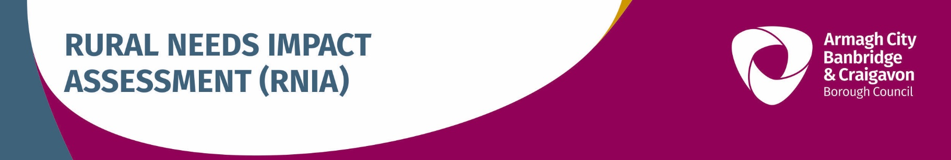

SECTION 1
Defining the activity subject to Section 1(1) of the Rural Needs Act (NI) 2016

1A. Name of Public Authority
Armagh City, Banbridge and Craigavon Borough Council

1B. Please provide a short title which describes the activity being undertaken by the Public Authority that is subject to Section 1(1) of the Rural Needs Act (NI) 2016
ABC Agriculture Strategy

1C. Please indicate which category the activity specified in Section 1B above relates to
Developing a | Policy |  | Strategy | x | Plan
Adopting a | Policy |  | Strategy |  | Plan
Implementing a | Policy |  | Strategy | x | Plan
Revising a | Policy |  | Strategy |  | Plan
Designing a Public Service
Delivering a Public Service

1D. Please provide the official title (if any) of the Policy, Strategy, Plan or Public Service document or initiative relating to the category indicated in Section 1C above
ABC Agriculture Strategy

1E. Please provide details of the aims and/or objectives of the Policy, Strategy, Plan or Public Service
The aim is to develop a strategy for the Agriculture Industry in the Borough looking ahead to the next 5 years at minimum, implementing recommendations which will address specific challenges, opportunities and needs for the industry. It will be built upon findings from research, surveys and engagement with stakeholders, and will contain recommendations to increase productivity, improve resilience, maintain and expand the capabilities of the agricultural industry, contribute positively to the supply chain.

1F. What definition of ‘rural’ is the Public Authority using in respect of the Policy, Strategy, Plan or Public Service?
Population Settlements of less than 5,000 (Default definition). | x
Other Definition (Provide details and the rationale below).
A definition of ‘rural’ is not applicable.

Details of alternative definition of ‘rural’ used.

Rationale for using alternative definition of ‘rural’.

Reasons why a definition of ‘rural’ is not applicable.

SECTION 2
Understanding the impact of the Policy, Strategy, Plan or Public Service

2A. Is the Policy, Strategy, Plan or Public Service likely to impact on people in rural areas?
Yes | x | No |  | If the response is NO GO TO Section 2E.

2B. Please explain how the Policy, Strategy, Plan or Public Service is likely to impact on people in rural areas.
The strategy will impact the farming community those that reside in open countryside and wider rural areas who are involved in the Agriculture Industry.
The strategy will benefit the wider farming, agri and rural community. The policy will provide skills development and improved communication methods to each farmer in the borough and develop delivery plans to support health, wellbeing and safety of our farmers. There is an opportunity to raise awareness of “women in farming” as raised during the consultation survey feedback.
There are nine recommendations in the strategy which have been developed to address challenges opportunities and needs for the industry in our borough.
1. Expand and evolve Food Heartland
2. Develop a method of communicating regularly and clearly with every Agriculture and Agri Food business in the Borough
3. Develop a plan to facilitate skills development in the Agriculture and Agri business
4. Appoint Agriculture Champions for the Borough
5. Develop an Agriculture Centre for advice, training, demonstration and research.
6. Facilitate structural upgrading
7. ABC Rural Strategy
8. Further studies in agriculture sectors
9. Agri Food development

2C. If the Policy, Strategy, Plan or Public Service is likely to impact on people in rural areas differently from people in urban areas, please explain how it is likely to impact on people in rural areas differently.
The strategy is directed at the Agriculture Industry (farmers and agri businesses) which are majority located in rural areas, with exception to agri food manufacturers located on the periphery of our urban areas within the edge of town industrial estates (still outside the town centre boundary).

This strategy may have the potential to benefit businesses in the agri food/hospitality industry within urban centres.

Engagement will be led through Food Heartland as per recommendation one.

2D. Please indicate which of the following rural policy areas the Policy, Strategy, Plan or Public Service is likely to primarily impact on.
Rural Businesses | x
Rural Tourism | x
Rural Housing
Jobs or Employment in Rural Areas
Education or Training in Rural Areas | x
Broadband or Mobile Communications in Rural Areas | x
Transport Services or Infrastructure in Rural Areas
Health or Social Care Services in Rural Areas
Poverty in Rural Areas
Deprivation in Rural Areas
Rural Crime or Community Safety
Rural Development | x
Agri-Environment | x
Other (Please state) Farming and farming families

If the response to Section 2A was YES GO TO Section 3A.

2E. Please explain why the Policy, Strategy, Plan or Public Service is NOT likely to impact on people in rural areas.
N/A

SECTION 3
Identifying the Social and Economic Needs of Persons in Rural Areas

3A. Has the Public Authority taken steps to identify the social and economic needs of people in rural areas that are relevant to the Policy, Strategy, Plan or Public Service?
Yes | x | No |  | If the Response is NO GO TO Section 3E.

3B. Please indicate which of the following methods or information sources were used by the Public Authority to identify the social and economic needs of people in rural areas.
Consultation with Rural Stakeholders | x | Published Statistics | x
Consultation with Other Organisations | x | Research Papers
Surveys or Questionnaires | x | Other Publications
Other Methods or Information Sources (include details in Question 3C below). |  |  | x

3C. Please provide details of the methods and information sources used to identify the social and economic needs of people in rural areas including relevant dates, names of organisations, titles of publications, website references, details of surveys or consultations undertaken etc.
The project has consulted across the industry at various stages to gather evidence and knowledge transfer in order to identify challenges, opportunities and needs. Refer to the timeline of engagement below;
Two surveys, one aimed at farmers (73 responses) and one aimed at agri businesses (57 responses) total responses received from the industry was 130 returns
Engagement with DAERA, AFBI, Rural Support, UFU, SRC, Cafre, INVEST NI, Agri-Food Quest at Queens University and Council Sections

DATE | Consultation Group
Ongoing | Engagement with DAERA, AFBI, Rural Support, UFU, SRC, Cafre, INVEST NI, Agri-Food Quest at Queens University and Council Sections (see below).
Ongoing | Conversations with Agri Businesses
January 2021 | Internal across departmental workshop using menti-meter
February 2021 | Individual consultation sessions with key Council Sections throughout February;  - SOAR  - Food Heartland  - Mid-South West  - Tannaghmore Gardens & Farm, Biodiversity Team and Sustainable Farming Projects  - Community Planning, Community Development & Equality Officer  - Policing Community and Safety Partnership (PCSP)  - Planning officers  - Environmental Health
16 February 2021 | Elected Members presentation and workshop – evening
16 February 2021 | Presentation and discussion with ICBAN
24 February 2021 | Elected Members presentation and workshop – morning
11 May 2021 | Presentation at EDR committee workshop
11 June to 4 July 2021 | Farmers Survey – open to the public with 73 responses
5 July to 11 August 2021 | Agri Business Food Survey – open to the public with 57 responses
1 September 2021 | External Stakeholder engagement and feedback session
7 September 2021 | Agri Businesses engagement and feedback session
14 September 2021 | Presentation to Economic Development and Regeneration Committee
17 September to 15 October 2021 | Policy Screening and Rural Needs Impact Assessment exercise on Consultation Hub. All section 75 groups will be advised of their availability.

The Agricultural Census in Northern Ireland June 2020, states that the labour force in the borough accounts for the following 2665, full time farmers, 2559 part time farmers, 742 full time other workers, 568 part time other workers, and 961 casual other workers. Collectively there are 7495 people in the borough who work in the agriculture sector which represent 14.6% of the NI Agriculture labour workforce.

The EU Farm Structure Survey 2016, indicated that 30 percent of farmers in Northern Ireland had no spouse, ranging from 32 percent for those with Very Small businesses to 17 percent of those with Large businesses. Approximately half (48 percent) of farmers’ spouses contributed to the work of the farms. The median age for farmers in Northern Ireland in 2016 was 58 years, the same as 2013 and one year older than recorded in 2010. The survey showed that there were 6 percent of farmers under 35 years old in 2016 compared with 4 percent in 2013 and 5 percent in 2010. However, it is stressed that these figures refer only to the principal farmer in each business rather than to all farmers.

DAERA Farm Labour Statistics NI updated April 2020, indicated that the in Northern Ireland total farmers, spouses and other workers (2019) is represented by 78.4% male and 21.6% female within the Agriculture Industry. The industry remains to be male dominant.

The ABC Farmers Survey Q76 asked “do you believe there are barriers for entry or progression in the industry…?” The responses concluded that 64% felt this was not applicable, 12 % felt that age is a barrier and 9.5% felt that gender is a barrier. Several comments were made under this section in relation to young farmers and women’s representation in the industry.

The ABC Agri Business/Food Survey Q68 asked the same “do you believe there are barriers for entry or progression in the industry…?” The responses concluded that 82% felt this was not applicable, 3% felt that age is a barrier and 5% felt that gender is a barrier.

3D. Please provide details of the social and economic needs of people in rural areas which have been identified by the Public Authority?
The Farmers Survey in particular identifies a need to support the various age of farmers and gender inequality, general comments leaned towards the mis-representation of women in the agriculture industry. Both surveys the farmers and agri businesses identified a need for business skills and learning for this industry. These skills will be addressed under recommendation 1 and 3.

Two recommendations in the strategy will support these two groups. This Recommendation 2 (focusing on communication with the industry) Recommendation 4 (appointment of agriculture champions, including the consideration of a ‘panel of women farmers’) other recommendations which focus on skills training, learning and development will provide support.

In the delivery phase of the strategy there will be a focus on improved signposting of current service providers and support such as mental health and well being, and health & safety, and raising awareness of support facilities available in our borough.

Council in the past has had limited engagement with the farming community and the wider agriculture industry. This strategy will have a positive impact on all groups going forward as Council instil greater collaboration with agriculture stakeholders, representatives and as a result from the communication plan.

The evolution of Food Heartland (recommendation 1) will have a positive impact on the agriculture industry and the broad range of activities/programmes and support Food Heartland will be able to deliver under its new roles and responsibilities.

ABC Rural Statistics
Results from the 2011 Census show that just over half of the borough’s population (51%) lived in urban areas while just under half (49%) lived in rural areas. This is based on the NISRA default urban/rural settlement classification where settlements with a population greater than or equal to 5,000 are classified as urban while those with a population less than 5,000 are classified as rural. This compares to 63% urban and 37% rural for Northern Ireland overall.
Craigavon Urban Area (which includes Central Craigavon, Lurgan and Portadown), Banbridge, Armagh and Dromore are the four urban areas within the borough, all other settlements are classified as rural according to the NISRA default classification.

NISRA also provides the classification at Super Output Area (SOA) level. Armagh City, Banbridge and Craigavon Borough is made up of 87 SOAs of which 42 are classified as urban, 36 are classified as rural with a further 9 being mixed urban/rural. The rural areas cover a large part of the borough.
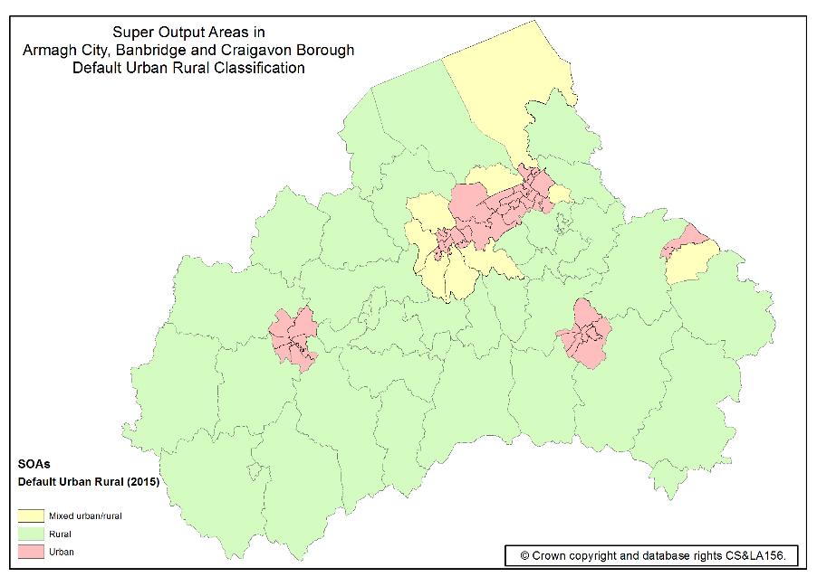
Figure 1: Super Output Areas in Armagh City, Banbridge and Craigavon Borough by NISRA default urban/rural classification.

The NI Multiple Deprivation Measure (NIMDM) 2017 provides information on seven distinct types of deprivation, known as domains, along with an overall multiple deprivation measure (MDM). Results are available for the 890 Super Output Areas in Northern Ireland, ranked from 1, most deprived to 890, least deprived.

The Access to Services Domain which measures the extent to which people have poor physical and online access to key services is particularly relevant to rural areas. The borough has nine SOAs (10% of the total 87 SOAs in the borough) in the top 100 most deprived in Northern Ireland on the Access to Services Domain, each of which are defined as rural on the NISRA default classification.

Twenty SOAs in Armagh City, Banbridge and Craigavon Borough (23% of the total 87 SOAs in the borough) are in the top 20% most deprived SOAs in Northern Ireland in terms of the Access to Services Domain. All twenty are classified as rural.
As well as the overall Access to Services deprivation, results are available for its three indicators:

- Service-weighted fastest travel time by private transport
- Service-weighted fastest travel time by public transport
- Proportion of properties with broadband speed below 10Mb/s
The top ten most deprived SOAs in the borough in terms of the Access to Services Domain are shown below, all of which are rural.
Super Output Area | Access to Services Domain Rank | Access to Services Indicators
 |  | Service-weighted fastest travel time by private transport (rank) | Service-weighted fastest travel time by public transport (rank) | Proportion of properties with broadband speed below 10Mb/s (rank)
Bannside | 18 | 100 | 57 | 2
Katesbridge | 33 | 43 | 53 | 33
Derrynoose | 54 | 67 | 41 | 72
Gransha | 64 | 42 | 32 | 178
Derrytrasna 2 | 73 | 56 | 187 | 30
Killylea | 89 | 38 | 86 | 143
The Birches 2 | 96 | 19 | 133 | 202
Quilly | 98 | 199 | 34 | 99
Carrigatuke | 100 | 96 | 84 | 94
Poyntz Pass | 101 | 129 | 116 | 51
Table 1: Top ten most deprived SOAs in Armagh City, Banbridge and Craigavon Borough in terms of the Access to Services Domain. Source: Northern Ireland Multiple Deprivation Measure 2017, NISRA.

Although not all are shown above, the borough has 11 SOAs in the top 100 most deprived in Northern Ireland for service-weighted fastest travel time by private transport, 10 for service-weighted fastest travel time by public transport and 11 for proportion of properties with broadband speed below 10Mb/s. Each of these SOAs are classified as rural.

The purpose of the Income Deprivation Domain is to identify the proportion of the population on low income. Armagh City, Banbridge and Craigavon Borough has nine SOAs (10% of the total 87 SOAs in the borough) in the top 100 most deprived in Northern Ireland on the Income Deprivation Domain. Three of these nine are rural areas according to the NISRA default classification.

The Living Environment Domain aims to identify the prevalence of shortcomings in the quality of housing, access to suitable housing and the outdoor physical environment. Figures for the Housing Quality Sub-Domain show the borough has eight of the top 100 most deprived SOAs in Northern Ireland of which four are rural.

If the response to Section 3A was YES GO TO Section 4A.

3E. Please explain why no steps were taken by the Public Authority to identify the social and economic needs of people in rural areas?

SECTION 4
Considering the Social and Economic Needs of Persons in Rural Areas

4A. Please provide details of the issues considered in relation to the social and economic needs of people in rural areas.
- Skills and business training availability and provision for the farmers and agri businesses.
- Labour shortages and automation for the industry
- Working long hours
- New technology and data analyzing training and support
- Health and welling being of farmers, farming families and people working in the wider agriculture industry
- Farm Business ID not being recognized as a business and not accessible to general business support
- Infrastructure in the rural areas, eg lack of broadband restricts business growth.
- Improving business productivity
- Effective communication required between council and farmers and agri businesses.

SECTION 5
Influencing the Policy, Strategy, Plan or Public Service

5A. Has the development, adoption, implementation or revising of the Policy, Strategy or Plan, or the design or delivery of the Public Service, been influenced by the rural needs identified?
Yes | x | No |  | If the response is NO GO TO Section 5C.

5B. Please explain how the development, adoption, implementation or revising of the Policy, Strategy or Plan, or the design or delivery of the Public Service, has been influenced by the rural needs identified.
Recommendations have been incorporated into the strategy to address feedback from stakeholders and the survey results. The recommendation will be council led, and will be delivered on a collaborative basis with stakeholders, therefore the relationship with stakeholders is important. It was identified that the communication between Council, farmers and agribusinesses should be improved and a communications plan put in place in order to engage effectively and make a difference to the rural businesses. Council in the past has had limited engagement with the farming community and the wider agriculture industry. This strategy will have a positive impact on all groups going forward as Council instil greater collaboration with agriculture stakeholders, representatives and as a result from the communication plan.

The Farmers Survey in particular identifies a need to support the various age of farmers and gender inequality, general comments leaned towards the mis-representation of women in the agriculture industry. Both surveys the farmers and agri businesses identified a need for business skills and learning for this industry. These skills will be addressed under recommendation 1 and 3.

Two recommendations in the strategy will support these two groups. Recommendation 2 (focusing on communication with the industry) Recommendation 4 (appointment of agriculture champions, including the consideration of a ‘panel of women farmers’) other recommendations which focus on skills training, learning and development will provide support.

In the delivery phase of the strategy there will be a focus on improved signposting of current service providers and support such as mental health and well being, and health & safety, and raising awareness of support facilities available in our borough.

The evolution of Food Heartland (recommendation 1) will have a positive impact on the agriculture industry and the broad range of activities/programmes and support Food Heartland will be able to deliver under its new roles and responsibilities.

If the response to Section 5A was YES GO TO Section 6A.

5C. Please explain why the development, adoption, implementation or revising of the Policy, Strategy or Plan, or the design or the delivery of the Public Service, has NOT been influenced by the rural needs identified.
N/A

SECTION 6
Documenting and Recording

6A. Please tick below to confirm that the RNIA Template will be retained by the Public Authority and relevant information on the Section 1 activity compiled in accordance with paragraph 6.7 of the guidance
I confirm that the RNIA Template will be retained and relevant information compiled. | x

Rural Needs Impact Assessment undertaken by: | Lissa O’Malley
Position/Grade: | Regeneration Manager
Department/Directorate | Armagh City, Banbridge and Craigavon Borough Council
Signature:
Date: | 06.09.21
Rural Needs Impact Assessment approved by: | Olga Murtagh
Position/Grade: | Strategic Director: Community and Growth
Department/Directorate | Armagh City, Banbridge and Craigavon Borough Council
Signature:
Date:

Northern Ireland is split into 890 spatial areas known as Super Output Areas (SOAs), with an average population of around 2,100 people.

